**CLASS – 3RD GIRLS**

**We are the students of**

**Aman English Medium School**

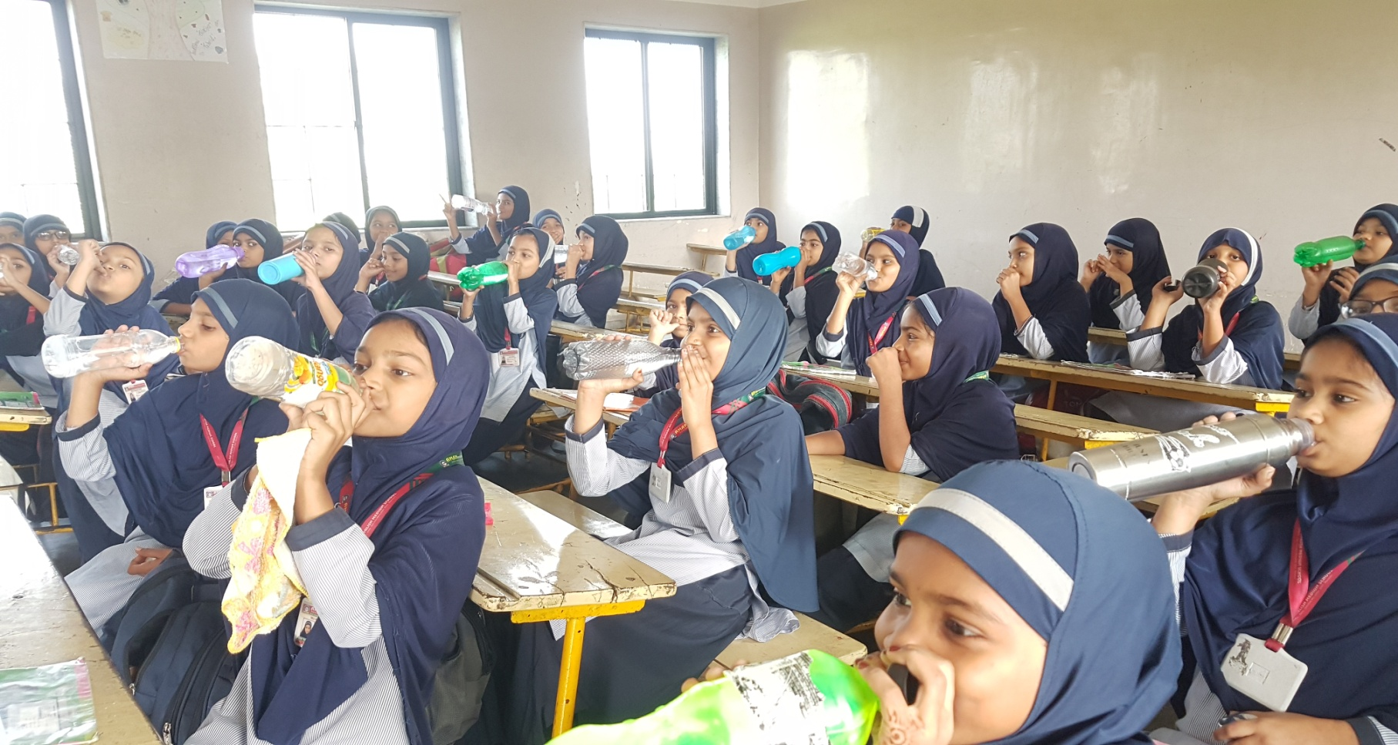

**We all are support to this chain of Drinking water**

**I’m Participating too.**